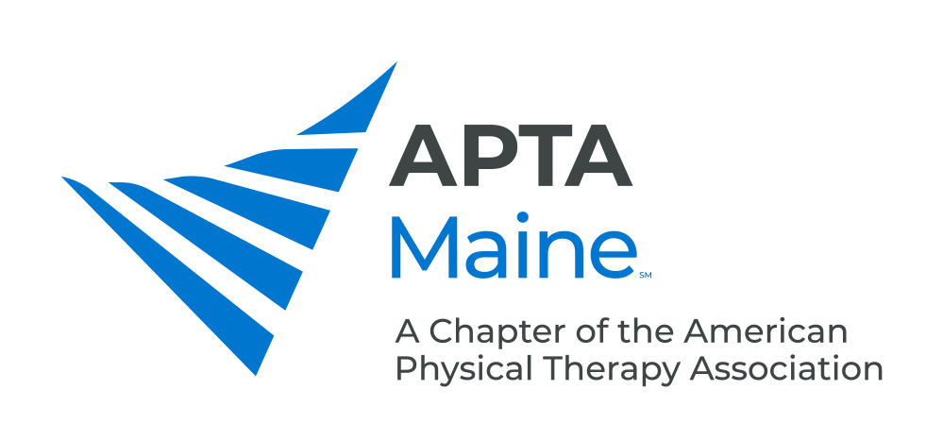

Continuing Education Payment Information Instructions

We are excited that you will be joining us for the December 4th Continuing Education Sessions! Please see below for instructions on payment.

Payment Options
- Credit Card
  - Complete the information below and email this form to the Executive Director at nichole_maine@orthopt.org

    - Name on card: _____________________________________________
    - Card number: _____-_____-_______________________
    - Expiration Date: ____/_____
    - Security Code: ______
    - Authorized Signature: ____________________________________
  - If you prefer to submit payment over the phone, please Contact the MAINE Chapter Executive Director during regular business hours (8am to 4pm CST) to complete your credit card payment over the phone; 800-444-3982 x2070

- Check
  - Payable to the Maine Chapter, APTA

  - Mail to Nichole Walleen, Executive Director, Maine Chapter, APTA, 2920 East Avenue South, Ste 200, LaCrosse, WI, 54601

Thank you for join us for the Continuing Education Sessions on December 4th!
Contact Nichole Walleen, ACEWM Executive Director, at nichole_maine@orthopt.org with questions.

