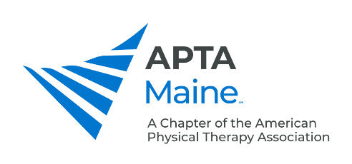

Student SIG organization/elected positions:

Student SIG Nominating Committee:

Reports to: The board members of the Student SIG

Responsibilities:
1. At least one month prior to the 1st Quarter Board Meeting, notify the SIG board of directors of all open elected positions, and ask for candidate recommendations.

2. Share pertinent material from the chapter policy & procedure manual with potential candidates, including job description, calendar, strategic plan, etc, and have them submit necessary forms.

3. Create a draft slate and submit a call for “nominations from the floor” to the Executive Director to include in the member newsletter (goal is to do this by August 1, but definitely no later than 60 days prior to fall membership meeting, per bylaws). Assistance is available from the Executive Director.

4. Review the qualifications of the nominees (must be chapter members meeting the qualifications for office per bylaws) shall be considered by the committee. Assistance is available from the Executive Director.

5. Select the best qualified candidates for each vacancy to be filled (two candidates per position is ideal), and notify nominees regarding whether or not they were slated.

6. Submit final slate and candidate forms to the Executive Director of the Chapter for creation of online ballot and mail ballots for those without email on file (goal is by September 1 to allow time to build online voting mechanism; ballot must be launched no later than 30 days prior to fall membership meeting, per bylaws).

7. Close voting after fall membership meeting; Executive Office counts the ballots and notified Developed 3/15 Nominating Committee of results.

8. Contact candidates with results and create an announcement for the Executive Director to include in the member newsletter (goal is to do this by December 1, but definitely no later than 45 days after 3rd quarter membership meeting, per bylaws).

9. Assist with filling other vacant (non-Board) positions and/or assisting VP with award nominations, as needed.
10. Fulfill general Board of Directors responsibilities (participate in SIG meetings and annual strategic planning; fulfill communication and reporting requirements; contribute to the newsletter, social media and update website as appropriate when authorized by the Chapter; respond to occasional member queries).

Position Objectives:
Represents the Maine Chapter of the APTA Student SIG. Lead the effort to fill vacant positions in the SIG. Serve on the Board of Directors of the SIG.

Qualifications:
Must fulfill qualification requirements outlined in the chapter bylaws.

Training and Evaluation:
You will be oriented by your predecessor and/or SIG chair or Vice Chair along with a board liaison. You will be given the opportunity to provide feedback periodically on the functionality of the SIG. The goal of the evaluation process is to improve the function of the SIG and to provide personal and professional development for you.

